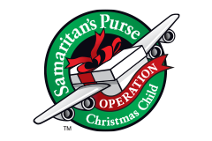
Christmas Shoebox List
Boys Ages 2-4
NECESSARY ITEMS:
- Washrag
- Bar Soap
- Soap Holder
- Toothbrush
- Toothbrush holder
- Bandaids
- Qtips
- Comb/Brush
- Wipes

Optional Items (in this box):
- Toy Car/Truck
- Blocks
- Coloring Book
- Crayons
- Small notepad
- Stickers
- Beach ball
- Toy Tambourine

Optional Replacement Items:
- Other small toys

