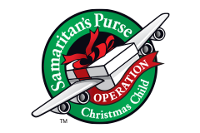
Girls Ages 5-9
NECESSARY ITEMS:
- Washrag
- Bar Soap
- Soap Holder
- Toothbrush
- Toothbrush holder
- Bandaids
- Qtips
- Comb/Brush
- Wipes
Optional Items: (in this box)
- Craft Sets (Provided by Church) Room for this item needs to be accounted for.
- Coloring Book
- Crayons
- Pencils
- Erasers Optional Replacement Items:
- Small Pencil Sharpeners 1. Stuffed Animals
- Pens
- Glue Sticks
- Notepad
- Flashlight
- Batteries (for flashlight)
- Jump Rope
- Make-up Kit
- Toy Jewelry
- Small Puzzle
- Toy Pom Poms
- Beach Ball
- Hair Bows

